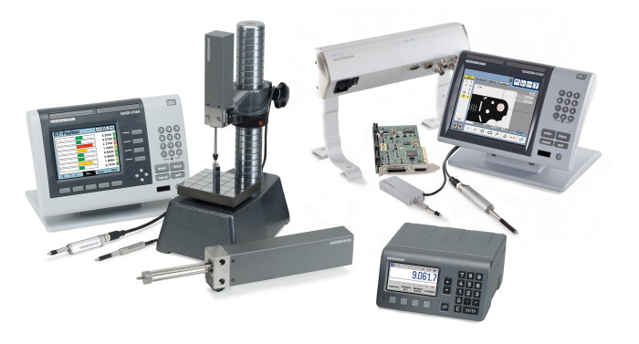
Please email completed form to Stuart Graham at sgraham@heidenhain.com

All Trainings take place at the US HQ at:
222 Remington Road, Schaumburg IL, 60173.
The goal is to provide training and support for HEIDENHAIN OEMs and Distributors so that you can go out and support and train your customers and provide added value to the end user. It is for this reason that this training is free for all HEIDENHAIN OEMs and Distributors.
Trainings can be scheduled for 1-3 people on any available date, please propose a start and end date below. These individual trainings will be geared toward the participant’s specific needs in the Metrology field, so bring your questions and applications!
Please take a moment and fill out the grayed portions of the form below. In your descriptions of what you would like to accomplish, please be as thorough as possible, so that we may tailor the discussion appropriately. Feel free to include detail using the “Other” sections below.
Attendee(s) Name: [Name]
Company: [Company Name]
Address: [Company Address]
Email: [Company E-mail]
Phone: [Company Phone]
Proposed Start Date of Training: Click here to enter a date.
End Date: Click here to enter a date.
What HEIDENHAIN Products do you wish to train with? Choose an item. Or Other

What type of Machine do you want to train on? Choose an item. Or Other

What level of training are you looking for? Choose an item. Or Other

